AUDITION PACKET
Blithe Spirit
By Noel Coward

Directed Tamara Benson
For information: 330.440.1348
www.TheLittleTheatreOnline.org

AUDITIONS: Saturday, JULY 31ST at 430 pm and Sunday AUGUST 1ST at 130 pm
**Please note casting will be done by Wednesday. Those not cast - may or may not receive an individual phone call.

WHAT DO I NEED FOR AUDITIONS?: Auditions will consist of a cold read from the script. Sample pages are attached, and full scripts can be loaned from the theater. Bring your completed audition form and a calendar reflecting any conflicts with you.

REHEARSAL & PERFORMANCE INFORMATION:
Rehearsals will begin August 15, 2021
Performances will be held: Oct. 8-10, 15-17, 22-24

ABOUT THE SHOW:
Time Period - 1940s / WWII
Settings Of Play - The living room of Charles Condomine's house in Kent, England.

The smash comedy hit of the London and Broadway stages, this much-revived classic from the playwright of Private Lives offers up fussy, cantankerous novelist Charles Condomine, re-married but haunted (literally) by the ghost of his late first wife, the clever and insistent Elvira who is called up by a visiting “happy medium,” one Madame Arcati. As the (worldly and un-) personalities clash, Charles’ current wife, Ruth, is accidentally killed, “passes over,” joins Elvira, and the two “blithe spirits” haunt the hapless Charles into perpetuity.

To read an excerpt visit: http://www.samuelfrench.com/content/samples/102416/3_BlitheSpirit.pdf

CHARACTER BREAKDOWN:
EDITH - a maid
RUTH - Charles’ current wife. She is a smart-looking woman in the middle thirties.
CHARLES - husband to Ruth and, before her passing, to Elvira. He is a nice looking man of about forty. DR. BRADMAN - pleasant-looking middle-aged man.
MRS. BRADMAN - fair and rather faded.
MADAME ARCATI - a medium. a striking woman between the age of fourty-five and sixty-five. ELVIRA - Charles' late wife

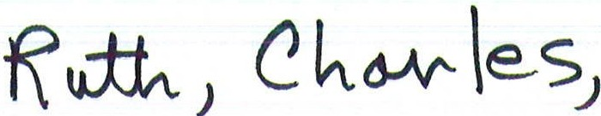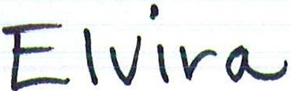
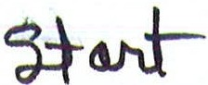
RUTH: Listen, Charles-you just sit down quietly by the fire and I'll mix you another drink. Don't worry about the mess on the. carpet-Edith can clean it up in the morning.
(She takes him by the arm.)

CHARLES (breaking away): But you must be able to see her-she's there-look-right in front of you-there

RUTH: Are you mad? What's happened to you? CHARLES: You can't see her?
RUTH: If this is a joke, dear, it's gone quite far enough. Sit down for God's sake and don't be idiotic.

CHARLES (clutching his head): What am I to do-what the hell am I to do!

ELVIRA: I think you might at least be a little more pleased to see me- after all, you conjured me up.

CHARLES (above table left centre): I didn't do any such thing.

ELVIRA: Nonsense, of course you did. That awful child with the cold came and told me you wanted to see me urgently.

CHARLES: It was all a mistake-a horrible mistake.

RUTH: Stop talking like that, Charles- as I told you before, the joke's gone far enough. CHARLES: I've gone mad, that's what it is-I've just gone raving mad.
RUTH (pours out brandy and brings it to CHARLES below piano): Here-drink this. CHARLES ( mechanically-taking it): This is appalling!

RUTH: Relax.

CHARLES: How can I relax? I shall never be able to relax again as long as I live. RUTH: Drink some brandy.
CHARLES (drinking it at a gulp): There, now-are you satisfied? RUTH: Now sit down.
CHARLES: Why are you so anxious for me to sit down-what good will that do? RUTH: I want you to relax- you can't relax standing up.

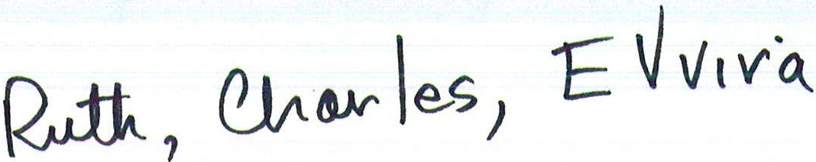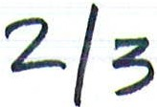

ELVIRA: African natives can-they can stand on one leg for hours. CHARLES: I don't happen to be an African native.
RUTH: You don't happen to be a what? CHARLES (savagely): An African native! RUTH: What's that got to do with it?
CHARLES: It doesn't matter, Ruth-really it doesn't matter. CHARLES crosses to arm-chair and sits.

CHARLES: See, I've sat down.

RUTH: Would you like some more brandy? CHARLES: Yes, please.
ELVIRA: Very unwise- you always had a weak head. CHARLES: I could drink you under the table.
RUTH: There's no need to be aggressive, Charles-I'm doing my best to help you. CHARLES: I'm sorry.
RUTH (crosses to up stage of CHARLES with brandy): Here-drink this-and then
we'll go to bed.

ELVIRA: Get rid of her, Charles- then we can talk in peace.

CHARLES: That' s a thoroughly immoral suggestion, you ought to be ashamed of yourself.

RUTH: What is there immoral in that? CHARLES: I wasn't talking to you.
RUTH: Who were you talking to, then? CHARLES: Elvira, of course.
RUTH: To hell with Elvira!

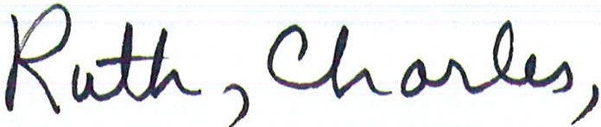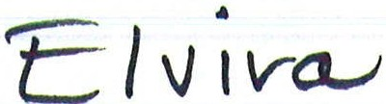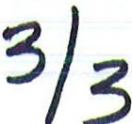

ELVIRA: There now- she' s getting cross. CHARLES: I don't blame her.
RUTH: Now look here, Charles-I gather you've got some sort of plan behind all this. I'm not quite a fool.

CHARLES: Don't be so silly-what plan could I have?

RUTH: I don't know- it' s probably something to do with the characters in your book­
ho.w they., or one of them would react to a certain situation-I refuse to be used as a gmnea-p1g.

CHARLES (moves a couple of paces towards RUTH): Elvira is here, Ruth-she's standing a few yards away from you.

RUTH (sarcastically): Yes, dear, I can see her distinctly-she's riding a zebra! CHARLES: But, Ruth ...
RUTH: I am not going to stay here arguing any longer ... ELVIRA: Hurray!
CHARLES: Shut up!

RUTH (incensed): How dare you speak to me like that! CHARLES: Listen, Ruth-please listen- -
RUTH: I will not listen to any more of this nonsense- I am going up to bed now, I'll leave you to turn out the lights.

ELVIRA: That' s big of her.
CHARLES: Be quiet-you're behaving like a guttersnipe. RUTH (icily): Good-night, Charles.
RUTH walks swiftly out of the room without looking at him again.

CHARLES (follows RUTH): Ruth ...

ELVIRA: That was one of the most enjoyable half-hours I have ever spent.

CHARLES (puts down glass on drinks table): This is obviously a hallucination!

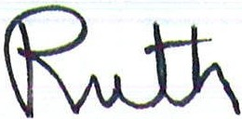
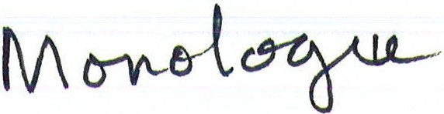
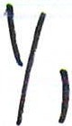
RUTH (furiously): I've been doing my level best to control myself ever since yesterday
morning and I'm damned if I'm going to try any more! It's been a nightmare- and I am not going to do it any more. I don't like Elvira any more than she likes me and what's more I'm certain that I never could have, dead or alive. All she has done is try to make mischief between us and have private jokes with you against me. I am now going up to my room and I shall have my dinner on a tray. You and she can have the house to yourselves and joke and gossip with each other to your heart's content. The first thing in the morning I am going up to London to the Psychical Research Society and if they fail me I shall go straight to the Archbishop of Canterbury.. ..
Exit RUTH.

CHARLES (making a movement to follow her): Ruth ...

ELVIRA: Let her go-she'll calm down later on.

CHARLES: It's unlike her to behave like this-she's generally so equable.

ELVIRA: No, she isn't, not really, her mouth gives her away-it's a hard mouth, Charles.

CHARLES: Her mouth's got nothing to do with it- I resent you discussing Ruth as though she were a horse.

ELVIRA: Do you love her? CHARLES: Of course I do. ELVIRA: As much as you loved me?
CHARLES: Don't be silly-it's all entirely different.

ELVIRA: I'm so glad. Nothing could ever have been quite the same, could it? CHARLES: You always behaved very badly.
ELVIRA: Oh, Charles!

CHARLES: I'm grieved to see that your sojourn in the other world hasn't improved you in the least.

ELVIRA: Go on, darling- I love it when you pretend to be cross with me....

CHARLES: I'm going up to talk to Ruth. ELVIRA: Cowardy custard.

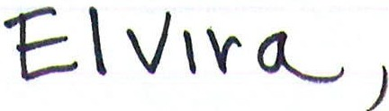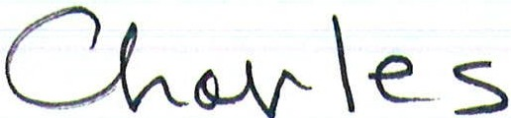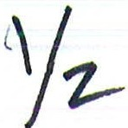

ELVIRA: I don't believe you want to take me at all.
CHARLES: Of course I want to take you, but I still think it would be more sensible to wait until to-morrow- it' s a filthy night.

ELVIRA (crosses and flings herself into arm-chair-crossly): How familiar this. CHARLES: In what way familiar?
ELVIRA: All through our married life I only had to suggest something for you immediately to start hedging me off- -

CHARLES: I'm not hedging you off, I merely said...

ELVIRA: All right-all right-we'll spend another cosy intimate evening at home with Ruth snapping at us like a terrier.

CHARLES: If you don't behave yourself! shan't take you into Folkestone ever.

ELVIRA (coaxingly): Please, Charles-Please let's go now. CHARLES: Not until I've had my sherry.
ELVIRA: You are tiresome, darling- I've been waiting about for hours....

CHARLES: A few more minutes won't make any difference then. (He pours himself out some sherry.)

ELVIRA (petulantly, flinging herself into a chair): Oh, very well. CHARLES: Besides the car won't be back for a half an hour at least. ELVIRA (sharply): What do you mean?
CHARLES (sipping his sherry nonchalantly): Ruth's taken it-she had to go and see the vicar....

ELVIRA (jumping up-in extreme agitation): What!! CHARLES: What on earth's the matter?
ELVIRA: You say Ruth's taken the car?

CHARLES: Yes-to go and see the vicar- but she won't be long. ELVIRA (rises): Oh, my God!

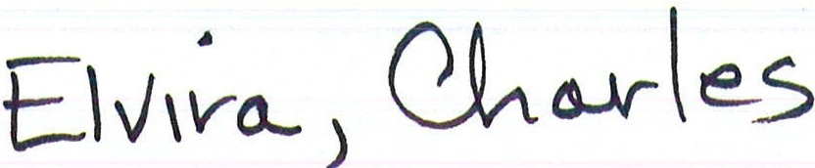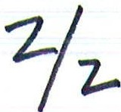

CHARLES: Elvira!

ELVIRA: Stop her- you must stop her at once....

CHARLES: Why-what for? ...

ELVIRA (jumping up and down): Stop her- go out and stop her immediately. CHARLES: It's too late now- I heard her go a couple of minutes ago....
ELVIRA (retreats backwards slowly towards window- CHARLES comes to her): Oh Oh Oh Oh!!!

CHARLES: What are you in such a state for?

ELVIRA (almost hysterical): I'm not in a state- I don't know what you mean.. .:

CHARLES (striking his forehead): My God the car! ELVIRA: No, Charles- no....
CHARLES: Ruth was right-you did want to kill me- you' ve done something to the car....

ELVIRA (howling like a banshee): Oh-oh-oh-oh!

CHARLES (steps towards her again): What did you do-answer me?
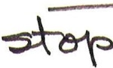
At this moment the telephone rings.

CHARLES (at telephone): Hallo-hallo-yes, speaking.... I see the bridge at the
bottom of the hill ... thank you- - No, I'll come at once.
He slowly puts back the receiver. As he does so the door bursts open. ELVIRA stands facing door.

ELVIRA (obviously retreating from someone): Well, of all the filthy low-down tricks. (She shields her head with her hands and screams.) Ow- stop it- Ruth- leave go- ­ She runs out of the room and slams the door. It opens again immediately and slams again. CHARLES stares aghast as the lights fade.

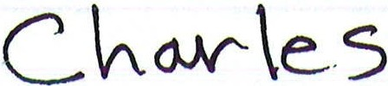
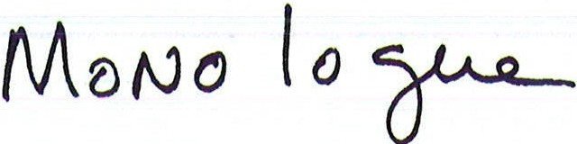
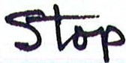
y,
away immediately.

CHARLES: But, Madame Arcati! You don't mean that ...?

MADAME ARCATI: (Nodding) There are more things in heaven and earth, Mr. Condomine. (She places her finger to her lips.) Just go-pack your traps and go as soon as possible. (Rises and goes to CHARLES.)

CHARLES (also in lowered tones): Do you mean that they may still be here?

MADAME ARCATI (she nods and then nonchalantly whistles a little tune. She collects her bag and her crystal, cards and Ouiji board).

CHARLES (looking furtively round the room): I'll follow your advice, Madame Arcati. Thank you again.

MADAME ARCATI: Good-bye, Mr. Condomine-it's been fascinating-from first to last-fascinating. Do you mind ifl take just one more sandwich to munch on my way home? (Gets sandwich from table.)

CHARLES: By all means.
MADAME ARCATI goes to the door. CHARLES follows her to see her safely out.

MADAME ARCATI (as they go): Don't trouble-I can find my way. Cheerio!
CHARLES watches her into the hall and then comes back into the room. He prowls 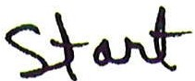 about for a moment as though he were not sure that be was alone.
CHARLES (Softly): Ruth-Elvira-are you there? (A pause.) Ruth-Elvira-I know damn well you're there--{Another pause.) I just want to tell you that I'm going away so there's no point in your hanging about any longer- I' m going a long way away­ somewhere where I don't believe you'll be able to follow me-in spite of what Elvira said I don't think spirits can travel over w ter. Is that quite clear, my darlings? You said in one of your more acid moments, Ruth, that I had been hag-ridden all my life! How right you were-but now I'm free, Ruth dear, not only of Mother and Elvira and Mrs.
Winthrop Llewelyn, but free of you too and I should like to take this farewell opportunity of saying I'm enjoying it immensely-
The vase on mantelpiece falls on to hearth-stone and smashes.
Aha-I thought so-you were very silly, Elvira, to imagine that I didn't know all about you and Guy Henderson-I did. But what you didn't know was that I was extremely attached to Paula Westlake at the time!
The picture above piano crashes to the ground.
I was reasonably faithful to you, Ruth, but I doubt if it would have lasted much longer­ you were becoming increasingly domineering, you know, and there's nothing more off­ putting than that is there?
The clock strikes sixteen very quickly.
Good-bye for the moment, my dears. I expect we are bound to meet again one day, but until we do I'm going to enjoy myself as I've never enjoyed myself before.

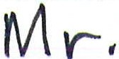
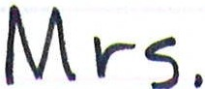
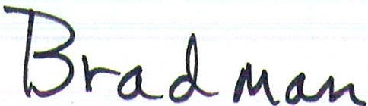
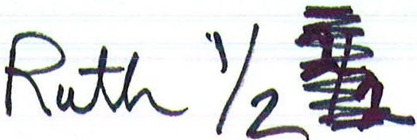
)
Act 2 Scene 3

The time is evening several days later.
When the curtain rises MRS. BRADMAN is sitting in an arm-chair. RUTH is standing by the window drumming on the pane with her fingers.

MRS. BRADMAN: Does it show any signs of clearing? RUTH: No, it’s still pouring.
MRS. BRADMAN: I do sympathise with you, really I do- it's really been quite a chapter of accidents, hasn't it?

RUTH: It certainly has. You're sure you wouldn't like a cocktail or some sherry or anything?

MRS. BRADMAN: No, thank you-really not-George will be down in a minute and we've got to go like lightning- we were supposed to be at the Wilmot's at seven and it's nearly that now.

RUTH (coming away from the window): I think I'll have a little sherry-I feel I need it.
(Moves up to table and pours sherry.)

MRS. BRADMAN: Don't worry about your husband's arm, Mrs. Condomine- I' m sure it's only a sprain.

RUTH: It's not his arm I'm worried about.

MRS. BRADMAN: And I'm sure Edith will be up and about again in a few days....

RUTH: My cook gave notice this morning.

MRS. BRADMAN: Well, really! Servants are awful, aren't they? Not a shred of gratitude-at the first sign of trouble they run out on you-like rats leaving a sinking ship.
RUTH: I can't feel that your simile was entirely fortunate, Mrs. Bradman. MRS. BRADMAN (flustered): Oh, I didn't mean that, really I didn't!
DR. BRADMAN comes in.

DR. BRADMAN: Nothing to worry about, Mrs. Condomine-it's only a slight strain....

RUTH: I'm so relieved.

DR. BRADMAN: He made a good deal of fuss when I examined it- men are much

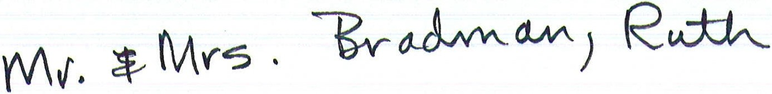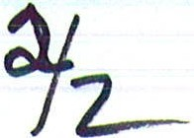

worse patients than women, you know-particularly highly strung men like your husband.

RUTH: Is he so highly strung, do you think?

DR. BRADMAN: Yes, as a matter of fact I wanted to talk to you about that. I'm afraid he's been overworking lately.

RUTH (frowning): Overworking?

DR. BRADMAN: He's in rather a nervous condition. Oh, nothing to be unduly alarmed about- a certain air of strain-an inability to focus his eyes on the person he is talking to-a few rather marked irrelevancies in his conversation.

RUTH: I see. Can you remember any specific example?

DR. BRADMAN: Oh, he suddenly shouted 'What are you doing in the bathroom?' and then, a little later, while I was writing him a prescription he suddenly said 'For God's sake behave yourself'

MRS. BRADMAN: How extraordinary.

RUTH (nervously): He often goes on like that-particularly when he's immersed in writing a book- -

DR. BRADMAN: Oh, I am not in the least perturbed about it really- but I do think a rest and a change would be a good idea.

RUTH: Thank you so much, Doctor. How is poor Edith?

DR. BRADMAN: She'll be all right in a few days-she's still recovering from the concussion.

MRS. BRADMAN: It's funny, isn't it, that both your housemaid and your husband should fall down on the same day, isn't it?

RUTH: Yes, if that sort of thing amuses you.

MRS. BRADMAN (giggling nervously): Of course I didn't mean it like that, Mrs. Condomine.

DR. BRADMAN: Come along, my dear.

CHARLES comes in. His left arm is in a sling. ELVIRA follows him in.

DR. BRADMAN: Well-how does it feel?

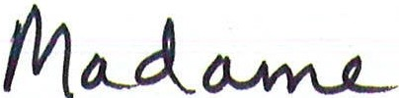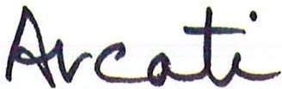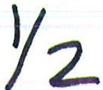

shall draw up this dear little stool and join you at the table-I shall place myself between you and your wife, Mr. Condomine, and rest my hands lightly upon yours-I must ask you not to address me or move or do anything in the least distracting- is that quite, quite clear?
CHARLES: Perfectly.
MADAME ARCATI: Of course, I cannot guarantee that anything will happen at all­ Daphne may be unavailable- she had a head cold very recently, and was rather under the weather, poor child. On the other hand, a great many things might occur-one of you might have an emanation, for instance, or we might contact a poltergeist which would be extremely destructive and noisy.... ·

RUTH: Anxiously In what way destructive?

MADAME ARCATI: They throw things, you know.

RUTH: I didn’t know.

MADAME ARCATI: But we must cross that bridge when we come to it, mustn't we?

CHARLES: Certainly—by all means.

RUTH: I’m so glad.

MADAME ARCATI: Now then-are you ready to empty your minds?

Dr. Bradman: Do you mean we’re to try to think of nothing?

MADAME ARCATI: Concentrate on a space or a nondescript colour that's really the best way....

Dr. Bradman: I’ll do my damndest.

MADAME ARCATI: Good work! I will now start the music.
She goes to the gramophone, puts on the record of ‘Always’, and begins to walk about the room; occasionally she moves into an abortive little dance step, and once, on passing a mirror on the mantelpiece , she surveys herself critically for a moment and adjusts her hair. Then with sudden speed, she runs across the room and switches off the lights.

Mrs. Bradman: Oh dear!

MADAME ARCATI: Quiet-please....
Presently in the gloom MADAME ARCATI, after wandering about a little, draws up a stool and sits at the table between CHARLES and RUTH. The gramophone record comes to an end. There is dead silence.

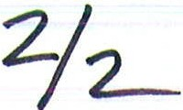
Is there anyone there? ... (A long pause.) ... Is there anyone there? ... (Another longer pause.) ... One rap for yes-two raps for no-now then-Is there anyone there? ... (After a shorter pause, the table gives a little bump.)

DR. BRADMAN: (involuntarily) Oh!

MADAME ARCATI: Sshhh! ... Is that you, Daphne? (The table gives a louder bump.) Is your cold better, dear? (The table gives two loud bumps very quickly.) Oh, I'm so sorry­ are you doing anything for it? (The table bumps several times.) I'm afraid she's rather fretful. (There is a silence.) Is there anyone there who wishes to speak to anyone here?
(After a pause the table gives one bump.) Ah! Now we're getting somewhere No,
Daphne, don't do that, dear, you're hurting me ... Daphne, dear, please ... Oh, oh, oh! ...
be good, there's a dear child You say there is someone there who wishes to speak to
someone here? (One bump.) Is it me? (Two sharp bumps.) Is it Dr. Bradman? (Two bumps.) Is it Mrs. Bradman? (Two bumps.) Is it Mrs. Condomine? (Several very loud bumps, which continue until MADAME ARCATI shouts it down.) Stop it! Behave yourself! Is it Mr. Condomine? (There is dead silence for a moment, and then a very loud single bump.) There's someone who wishes to speak to you, Mr. Condomine....

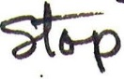
CHARLES: Tell them to leave a message.
The table bangs about loudly.

MADAME ARCATl: I really must ask you not to be flippant, Mr. Condomine....

RUTH: Charles, how can you be so idiotic- you' ll spoil everything. CHARLES: I'm sorry-it slipped out.
MADAME ARCATI: Do you know anybody who has passed over recently?

CHARLES: Not recently, except my cousin in the Civil Service, and he wouldn't be likely to want to communicate with me- we haven't spoken for years.
MADAME ARCATI: Are you Mr. Condomine's cousin in the Civil Service? (The table bumps violently several times.) I'm afraid we've drawn a blank Can't you think of
anyone else? Rack your brains....

RUTH (helpfully): It might be old Mrs. Plummett, you know-she died on Whit Monday....

CHARLES: I can't imagine why old Mrs. Plummett should wish to talk to me-we had very little in common.

RUTH: It's worth trying, anyhow.

MADAME ARCATI: Are you old Mrs. Plummett? (The table remains still.)

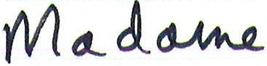
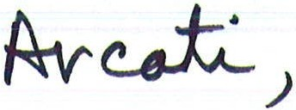
MADAME ARCATI: I will report the whole matter to the Society for Psychical Research at the earliest possible moment.

RUTH: Will they be able to do anything?

MADAME ARCATI: I doubt it. They'd send an investigation committee, I expect, and do a lot of questioning and wall tapping and mumbo jumbo

RUTH (near tears): It's too humiliating-it really is.

MADAME ARCATI (rises and goes to RUTH): Please try not to upset yourself­ nothing can be achieved by upsetting yourself. Try to look on the bright side.

RUTH: Bright side indeed! If your husband's first wife suddenly appeared from the grave and came to live in the house with you, do you suppose you'd be able to look on the bright side?

MADAME ARCATI: Kindly remember that I came here the other night on your own invitation. I had no idea that there was any ulterior motive mixed up with it.

RUTH: Ulterior motive?

MADAME ARCATI: Your husband was obviously eager to get in touch with his former wife.

RUTH: He had no intention of trying to get in touch with anyone- the whole thing was planned in order for him to get material for a mystery story he is writing about a homicidal medium.

MADAME ARCATI (drawing herself up): Am I to understand that I was only invited in a spirit of mockery?

RUTH: Not at all-he merely wanted to make notes of some of the tricks of the trade.

MADAME ARCATI (incensed): Tricks of the trade! Insufferable! I've never been so insulted in my life. I feel we have nothing more to say to one another, Mrs. Condomine­ Good-bye. (Turns away.)

RUTH: Please don't go-please- -

MADAME ARCATI (turns and faces RUTH): Your attitude from the outset has been most unpleasant, Mrs. Condomine. Some of your remarks have been discourteous in the extreme and I should like to say whatever has happened to you is your own fault and, to coin a phrase, as far as I'm concerned you can stew in your own juice!
MADAME ARCATI goes majestically from the room.
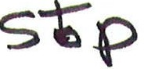

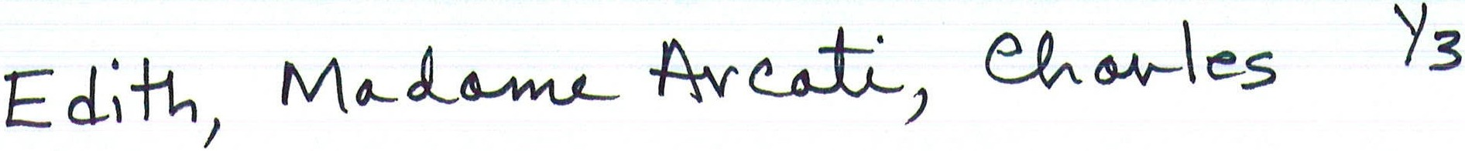

CHARLES: I haven't got a white bandage. MADAME ARCATI: Shhh!
ELVIRA: She's too good, you know-she ought to be in a circus.
MADAME ARCATI runs across and leaps on a chair. She raises her arms slowly- she begins to intone.

MADAME ARCATI: Be you in nook or cranny answer me, Be you in Still-room or closet answer me,
Be you behind the panel, above the stairs Beneath the eaves--waking or sleeping, Answer me!
That ought to do it.

CHARLES: Do what?

MADAME ARCATI: Hush-wait--
MADAME ARCATI crosses to window and picks up bunch of garlic and crosses to writing-desk, making cabalistic signs. She picks up one of the birch branches and waves it solemnly to and fro.

RUTH: For God's sake don't let her throw any more of that garlic about- it nearly made me sick last time.

CHARLES: Would you like the gramophone on or the lights out or anything? MADAME ARCATI: No, no-it's near- it's very near- -
ELVIRA: If it's a ghost I shall scream.

RUTH: I hope it's nobody we know-I shall feel so silly.
-
Suddenly the door opens and EDITH comes into the room. She is wearing a flannel dressing-gown and bedroom slippers. Her head is bandaged.

EDITH: Did you ring, sir?

MADAME ARCATI: The bandage! The white bandage! CHARLES: No, Edith.
EDITH: I'm sorry, sir- I could have sworn I heard the bell—or somebody calling-I was asleep....

MADAME ARCATI: Come here, child.

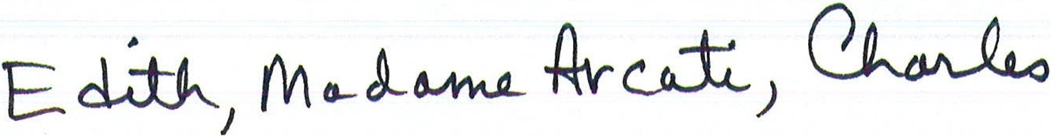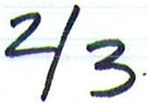

EDITH: Oh! (She looks anxiously at CHARLES.)

CHARLES: Go on-go to Madame Arcati- it's quite all right. MADAME ARCATI: Who do you see in this room, child?
EDITH: Oh dear....

MADAME ARCATI: Answer please.

EDITH (falteringly): You, Madame. (She stops.)

MADAME ARCATI: Go on.

EDITH: The Master.

MADAME ARCATI: Anyone else? EDITH: Oh, no, Madame.. ..
MADAME ARCATI (inflexibly): Look again.
EDITH (imploringly, to CHARLES): I don't understand, sir-I--MADAME ARCATI: Come, child- look again.
ELVIRA moves across to fireplace. RUTH follows. EDITH follows them with her eyes.

MADAME ARCATI: Do you see anyone else now? EDITH (slyly): Oh no, Madame.
MADAME ARCATI: She's lying. EDITH: Oh, Madame!
MADAME ARCATI (sharply): Where are they now? EDITH: By the fireplace--Oh!
CHARLES: She can see them--do you mean she can see them? MADAME ARCATI: Probably not very clearly-but enough
EDITH (bursting into tears): Let me go-I haven't done nothing nor seen nobody- let me go back to bed.

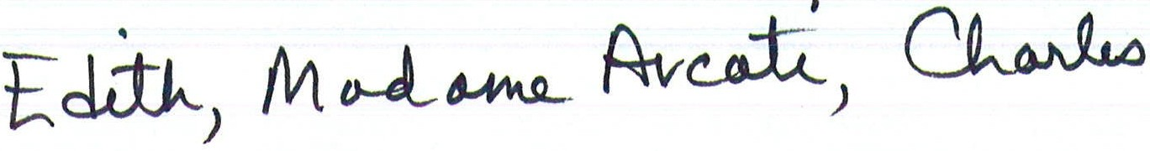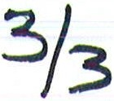

MADAME ARCATI: Sit down.

EDITH (to CHARLES): Please, sir, I ...

CHARLES: Please do as Madame Arcati says, Edith.

EDITH (sitting down and sniffing): I haven't done nothing wrong. CHARLES: It's all right- nobody said you had.
RUTH: If she’s been the cause of all this unpleasantness I’ll give her a week’s notice tomorrow.

ELVIRA: You may not be here tomorrow.

MADAME ARCATI: Look at me, Edith. EDITH obediently does so.

MADAME ARCATI: Here, Edith-this is my finger-look-(She waggles it.) Have you ever seen such a long, long finger- look now, it's on the right-now it's on the left­ backwards and forwards it goes--see--very quietly backwards and forwards--tic-toc­-tic-toc--tic-toc.

ELVIRA: The mouse ran up the clock.

Ruth: Be quiet—you’ll ruin everything.

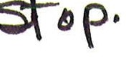
MADAME ARCATI whistles a little tune close to EDITH'S face- then she snaps her fingers. EDITH looks stolidly in front of her without flinching. MADAME ARCATI stands back.
---

MADAME ARCATI: She's a Natural- just the same as the Sudbury case- it really is the most amusing coincidence. Now then- would you ask your wives to stand close together, please.

CHARLES: Where?

MADAME ARCATl: Over there by you. CHARLES: Elvira- Ruth- -
RUTH: I resent being ordered about like this.

ELVIRA: I don't like this at all. CHARLES: I' m afraid I must insist.

